**REPORT ON MICRO AND SMALL ENTERPRISES**

**Subject :** Management And Entrepreneurship for IT Industry(17CS51)

**Submitted by,**

**ANUSHA HULLATTI 4VV17CS013**

**HARSHITHA B 4VV17CS039**

**MADHURA B S 4VV17CS043**

**NAVILE M 4VV17CS049**

**NIHARIKA M P 4VV17CS052**

**NIHARIKA M S 4VV17CS053**

**NISCHITHA N 4VV17CS057**

**PRATHIKSHA S MURTHY 4VV17CS066**

**NISHCHITHA RAJ T G 4VV16CS065**

**RASHMI H A 4VV17CS119**

**BHOOMIKA B S 4VV17CS121**



**DEPARTMENT OF COMPUTER SCIENCE AND ENGINEERING**

**VIDYAVARDHAKA COLLEGE OF ENGINEERING**

**MYSURU-570002**

**Enterprise:**  
 The definition of an **enterprise** is a project or willingness to take on a new project, an undertaking or business venture.

**Micro Enterprise :**

A micro-enterprise is generally defined as a small business employing nine people or fewer, and having a balance sheet or turnover less than a certain amount.

The terms microenterprise and **microbusiness** have the same meaning, though traditionally when referring to a small business financed by [microcredit](https://en.wikipedia.org/wiki/Microcredit) the term microenterprise is often used. Similarly, when referring to a small, usually legal business that is not financed by microcredit, the term microbusiness (or micro-business) is often used. Internationally, most microenterprises are family businesses employing one or two persons. Most microenterprise owners are primarily interested in earning a living to support themselves and their families. They only grow the business when something in their lives changes and they need to generate a larger income.

**Global definition :**

  The term microenterprise or microbusiness refers to different entities and sectors depending on the country.

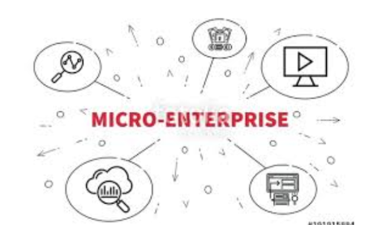

**Small Enterprise :**

A small enterprise is one marked by a limited number of employees and a limited flow of finances and materials.

Different government agencies and private organizations rely on different sets of criteria when talking about a small enterprise.

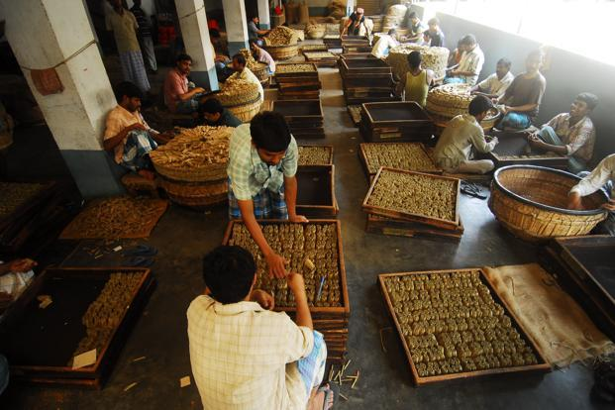

The Government of India has enacted the Micro, Small and Medium Enterprises Development (MSMED) Act, 2006 in terms of which the definition of micro, small and medium enterprises is as under:

* Enterprises engaged in the manufacture or production, processing or preservation of goods as specified below:
  + A micro enterprise is an enterprise where investment in plant and machinery does not exceed Rs. 25 lakh;
  + A small enterprise is an enterprise where the investment in plant and machinery is more than Rs. 25 lakh but does not exceed Rs. 5 crore;
  + A medium enterprise is an enterprise where the investment in plant and machinery is more than Rs.5 crore but does not exceed Rs.10 crore.  
    In case of the above enterprises, investment in plant and machinery is the original cost excluding land and building and the items specified by the Ministry of Small Scale Industries vide  
    its notification [No.S.O.1722(E) dated October 5, 2006](http://www.rbi.org.in/Scripts/bs_viewcontent.aspx?Id=577#_blank).
* Enterprises engaged in providing or rendering of services and whose investment in equipment (original cost excluding land and building and furniture, fittings and other items not directly related to the service rendered or as may be notified under the MSMED Act, 2006 are specified below.
  + A micro enterprise is an enterprise where the investment in equipment does not exceed Rs. 10 lakh;
  + A small enterprise is an enterprise where the investment in equipment is more than Rs.10 lakh but does not exceed Rs. 2 crore;
  + A medium enterprise is an enterprise where the investment in equipment is more than Rs. 2 crore but does not exceed Rs. 5 crore.

# **Characteristics :**

* Small-scale businesses display a distinct set of identifying characteristics that set them apart from their larger competitors.
* A small scale industry is generally a one man show even in cases where the small units are run by a partnership firm or a company; the activities are mainly carried out by one of the partners or directors.
* In SSIS the owner himself is a manager also and these units are managed in a personalized fashion. the owner gas not only the first hand knowledge of the ongoing business of the firm nut also takes effective participation in all matters of business decision taking.
* The SSIs have smaller gestation period as compared to larger SSIs that is the period after which the return of investment starts.
* Scope of SSI is generally localized catering the needs of local and regional demands.
* SSIs can be located anywhere use indigenous resources subject to the availability of these resources like raw material labor etc.
* SSIs are fairly labor intensive with comparatively smaller capital investment as small as 600- 700 rupees for an artisan and his family to begin with than the larger units.
* The development of the small scale industries in rural areas promotes balanced regional development due to the decentralization and utilization local resources and also prevents influx of job seekers from cities and urbanization.
* The small scale industries are more susceptible to change, highly reactive and receptive to socio-economic conditions.

**Advantages:**

* Many small businesses can be started at a low cost and on a part-time basis, while a person continues a regular job with an employer or provides care for family members in the home.
* In developing countries, many small businesses are sole-proprietor operations such as selling produce at a market stall or preparing hot food to sell on the street, that provide a small income.
* A small business is also well suited to Internet marketing because, it can easily serve specialized niche, something that would have been more difficult prior to the Internet revolution.
* Small business owners possess the flexibility and freedom to making their own decisions within the constraints imposed by economic and other environmental factors.
* Independence is another advantage of owning a small business.
* A small business owner does not have to report to a supervisor or manager. In addition, many people desire to make their own decisions, take their own risks, and reap the rewards of their efforts.
* The small enterprises are closed to the absorption of new knowledge and employing new labor from outside.

|  |  |
| --- | --- |
| Name | Signature |
| Anusha Hullatti |  |
| Harshitha B |  |
| Madhura B S |  |
| Navile M |  |
| Niharika M P |  |
| Niharika M S |  |
| Nischitha N |  |
| Prathiksha S Murthy |  |
| Nishchitha Raj T G |  |
| Rashmi H A |  |
| Bhoomika B S |  |